**Hands On assignment 5**

**MM19B027 - Bhuvanesh P**

1. **We try to plot Energy per atom for 0.5% compression and extension of the lattice parameter. The plot is given by**

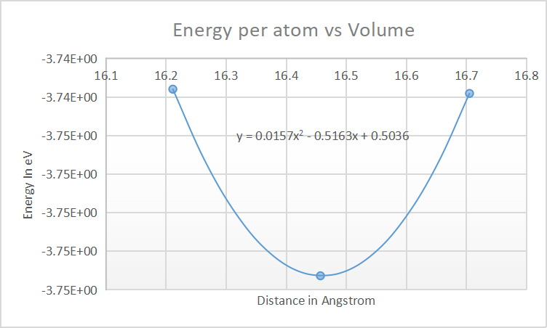

1. **Bulk Modulus is given by**

$B=V_{o} \frac{d^{2}E}{dV^{2}}$

E(V) is given by 0.0157V2 - 0.5163V + 0.5036

Here Vo is the equilibrium volume which obtained by differentiating the energy equation and equating it to 0

$\frac{dE}{dV}$ = 0 = 0.0314V - 0.5163

Which gives Vo as 16.44267 A3

The we double differentiate the energy equation y = 0.0157V2 - 0.5163V + 0.5036 to get $\frac{d^{2}E}{dV^{2}}$ = 0.0314

We get B = 0.0314 X 16.44267 = 0.5163 which is in eV/A3

To convert it into SI units, we do $0.5163 X \frac{1.6 X {10}^{−19} }{{10}^{−30}}$

We get 0.82608 X 10 11 Pa or 82.6 GPa . Experimental value is 76 Gpa. The deviation from the actual value is about 8.7 %.